Christian Concepcion

*10.3 Draw and annotate a class hierarchy that represents various types of sales transactions in a store (cash, credit, etc.). Show what characteristics would be represented in the various classes of the hierarchy. Explain how polymorphism could play a role in the payment process.*

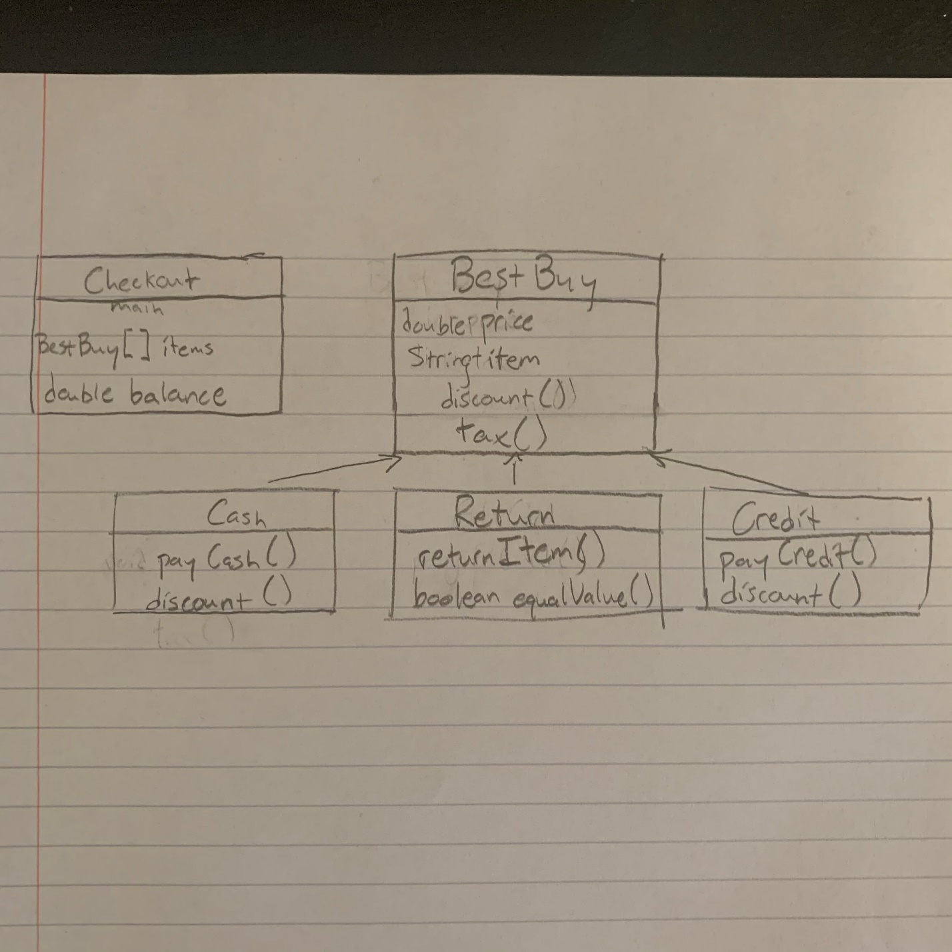

In the payment system of a store like Best Buy, polymorphism plays a role in what outside classes are impacted. For example, paying with cash involves taking money from your own pocket, which doesn’t involve a computer system but the cash you have on-hand is impacted. When paying with credit cards, the payment system sends information to your credit card’s bank, thus calling on a loaning system that pays for your purchase, putting the card in debt to the bank’s borrowing system. In the Return class, the store is instead paying you back for a pre-owned item, and the money you get back is determined by factors such as: amount of time since the initial purchase and the item’s usage. Overall, the payment system of a store has access to many different payment options.

*EX 10.4 What would happen if the pay method were not defined as an abstract method in the StaffMember class of the Firm program?*

If the *pay()* method was not defined as an abstract method in the *Firm* program, then it’s necessary for the programmer to write a body for that method. This method, if it’s from a parent class, can be overridden by its child classes in the same way the child class’ methods had written the abstract method.